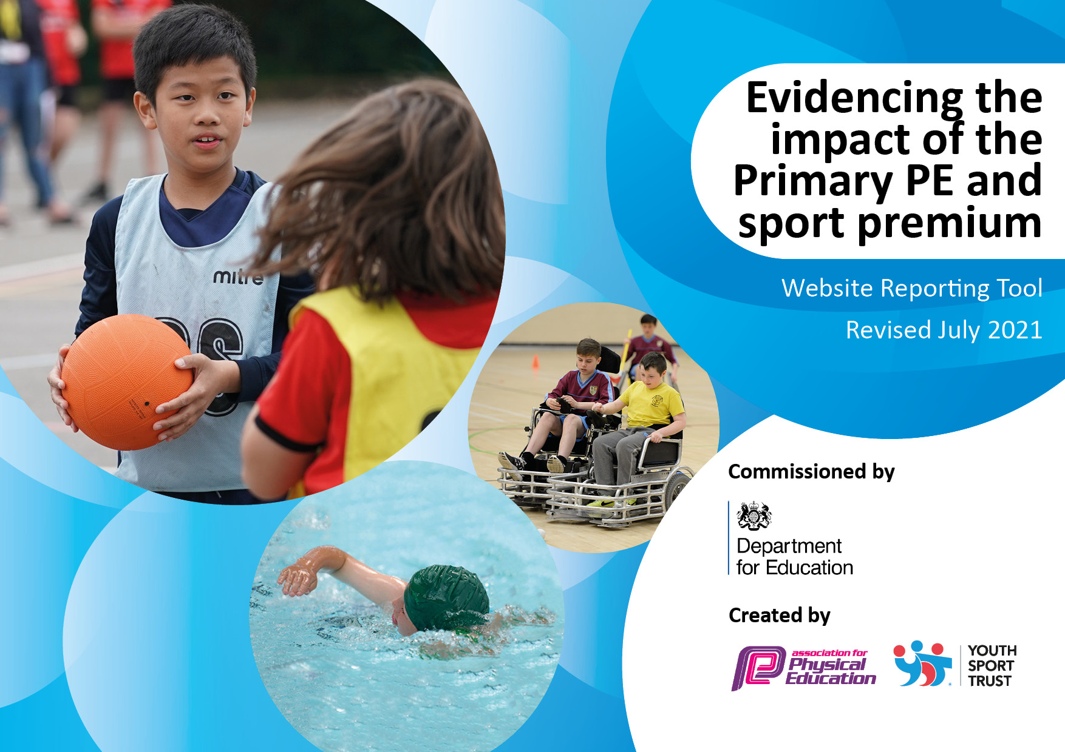

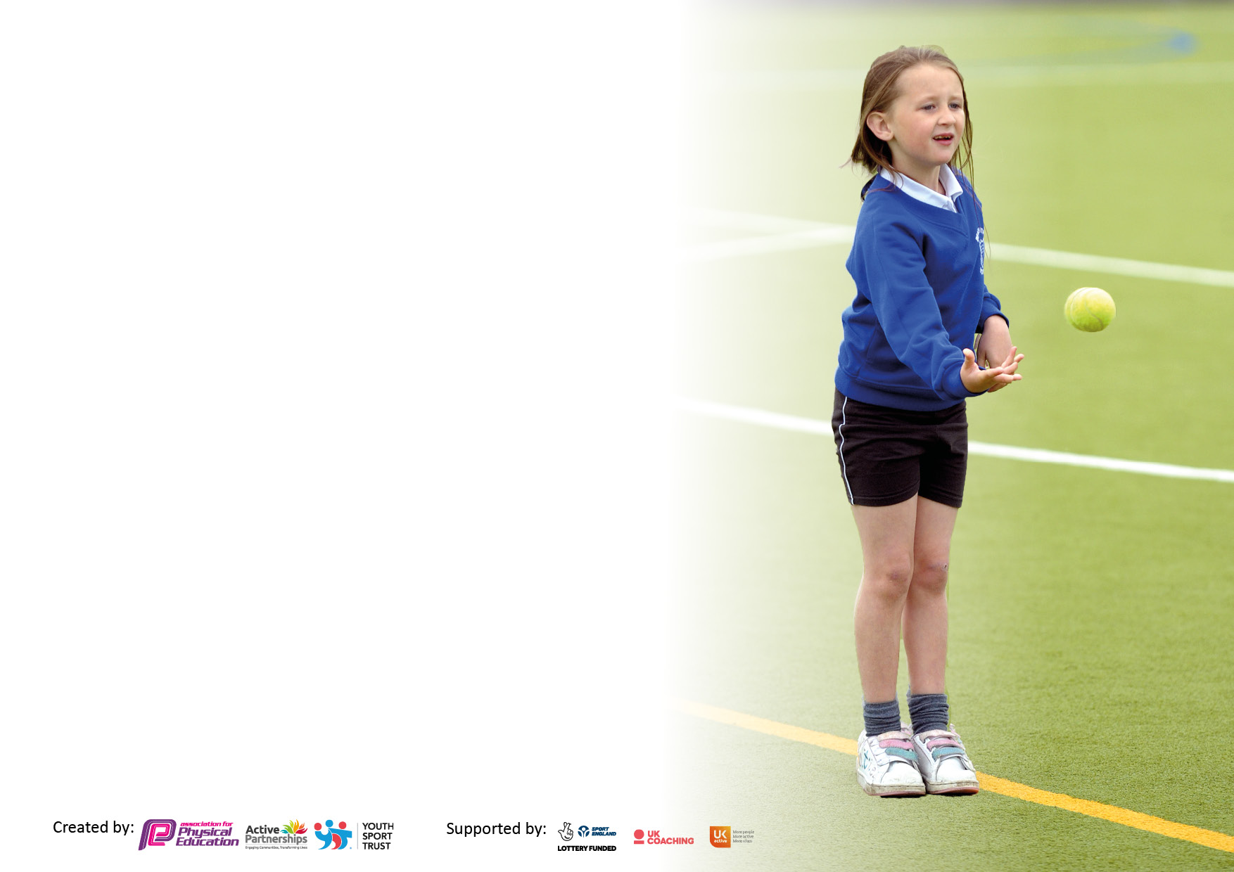

It is important that your grant is used effectively and based on school need. The [Education Inspection Framework](https://assets.publishing.service.gov.uk/government/uploads/system/uploads/attachment_data/file/843108/School_inspection_handbook_-_section_5.pdf) makes clear there will be a focus on **‘whether leaders and those responsible for governors all understand their respective roles and perform these in a way that enhances the effectiveness of the school’**.

Under the [Quality of Education](https://assets.publishing.service.gov.uk/government/uploads/system/uploads/attachment_data/file/843108/School_inspection_handbook_-_section_5.pdf) Ofsted inspectors consider:

**Intent** - Curriculum design, coverage and appropriateness

**Implementation** - Curriculum delivery, Teaching (pedagogy) and Assessment

**Impact** - Attainment and progress

To assist schools with common transferable language this template has been developed to utilise the same three headings which should make your plans easily transferable between working documents.

Schools must use the funding to make **additional and sustainable** improvements to the quality of Physical Education, School Sport and Physical Activity (PESSPA) they offer. This means that you should use the Primary PE and sport premium to:

* Develop or add to the PESSPA activities that your school already offer
* Build capacity and capability within the school to ensure that improvements made now will benefit pupils joining the school in future years
* The Primary PE and sport premium should not be used to fund capital spend projects; the school’s budget should fund these.

Pleasevisit[gov.uk](https://www.gov.uk/guidance/pe-and-sport-premium-for-primary-schools)fortherevisedDfEguidanceincludingthe5keyindicatorsacrosswhichschoolsshoulddemonstrate animprovement.Thisdocumentwillhelpyoutoreviewyourprovisionandtoreportyourspend.DfEencouragesschools to use this template as an effective way of meeting the reporting requirements of the Primary PE and sport premium.

We recommend you start by reflecting on the impact of current provision and reviewing the previous spend.

Schools are required to [publish details](https://www.gov.uk/guidance/what-maintained-schools-must-publish-online#pe-and-sport-premium-for-primary-schools) of how they spend this funding, including any under-spend from 2019/2020, as well as on the impact it has on pupils’ PE and sport participation and attainment. **All funding must be spent by 31st July 2022.**

We recommend regularly updating the table and publishing it on your website throughout the year. This evidences your ongoing self-evaluation of how you are using the funding to secure maximum, sustainable impact. Final copy must be posted on your website by the end of the academic year and no later than the 31st July 2021. To see an example of how to complete the table please click [HERE](http://www.afpe.org.uk/physical-education/wp-content/uploads/afPE-Example-Template-Indicator-2018-Final.pdf).



**Details with regard to funding**

Please complete the table below.

|  |  |
| --- | --- |
| Total amount carried over from 2019/20 | £ 0 |
| Total amount allocated for 2020/21 | £ NEED TO KNOW THIS FIGURE |
| How much (if any) do you intend to carry over from this total fund into 2021/22? | £ NEED TO KNOW THIS FIGURE |
| Total amount allocated for 2021/22 | £ NEED TO KNOW THIS FIGURE |
| Total amount of funding for 2021/22. To be spent and reported on by 31st July 2022. | £ NEED TO KNOW THIS FIGURE |

**Swimming Data**

Please report on your Swimming Data below.

|  |  |
| --- | --- |
| Meeting national curriculum requirements for swimming and water safety.  N.B. Complete this section to your best ability. For example you might have practised safe self-rescue techniques on dry land which you can then transfer to the pool when school swimming restarts.  **Due to exceptional circumstances priority should be given to ensuring that pupils can perform safe self rescue even if they do not fully meet the first two requirements of the NC programme of study** | No swimming was able to take place during this academic year due to Covid-19. |
| What percentage of your current Year 6 cohort swim competently, confidently and proficiently over a distance of at least 25 metres?  **N.B.** Even though your pupils may swim in another year please report on their attainment on leaving primary school at the end of the summer term 2020.  Please see note above | % |
| What percentage of your current Year 6 cohort use a range of strokes effectively [for example, front crawl, backstroke and breaststroke]?  Please see note above | % |
| **What percentage of your current Year 6 cohort perform safe self-rescue in different water-based situations?** | % |
| Schools can choose to use the Primary PE and sport premium to provide additional provision for swimming but this must be for activity **over and above** the national curriculum requirements. Have you used it in this way? | Yes/No |

**Action Plan and Budget Tracking**

Capture your intended annual spend against the 5 key indicators. Clarify the success criteria and evidence of impact that you intend to measure to evaluate for pupils today and for the future.

|  |  |  |  |  |
| --- | --- | --- | --- | --- |
| **Academic Year:** 2020/21 | **Total fund allocated:** | **Date Updated:** | |  |
| **Key indicator 1:** The engagement of all pupils in regular physical activity – Chief Medical Officers guidelines recommend that primary school pupils undertake at least 30 minutes of physical activity a day in school | | | | Percentage of total allocation: |
| 78% |
| **Intent** | **Implementation** | | **Impact** |  |
| Your school focus should be clear what you want the pupils to know and be able to do and about  what they need to learn and to  consolidate through practice: | Make sure your actions to achieve are linked to your intentions: | Funding allocated: | Evidence of impact: what do pupils now know and what can they now do? What has changed?: | Sustainability and suggested next steps: |
| **All children to receive one PE lesson per week from AVSSP coaches.** | All children to receive a weekly PE lesson from AVSSP over the academic year.  CPD opportunity for all school staff while supporting the delivery of lessons. | **£5425** | All children have taken part weekly PE sessions where they have improved their skills across the curriculum.  Staff feel more confident in delivery of PE lessons as a result of working alongside a specialist. | Carry on with AVSSP |
| **Have activity equipment available to pupils at lunch time. Purchase both physical activity and sporting equipment. Need enough equipment for each bubble to have access to their own equipment.** | Purchase of equipment for lunch use at lunch times. Organise into 5 age appropriate bags, one per class bubble. | **£380** | * Pupils to have a better experience of Physical activity and School Sport at lunch times * Lunch time staff to feel more comfortable delivering activity * Lunch times will have more variety of activity * Equipment will be able to be used at other times in the day | Look to develop the playground further by painting floor markings  Develop lunch time staff through training on how to use the equipment |
| **Play leader employed for lunchtime.** | Increase the activities on offer during a lunchtime.  Increase activity levels during lunchtime. | **£2763** | * Children have a more positive lunch time experience. * Increase in positive behaviour * Increase in activity levels * Improved teamwork and communication | * Budget for a play leader in the next academic year. |
| **Update the curriculum resources.** | With the help of the SSP coach, carry out an inventory of what equipment we already have and what needs to be ordered to enhance the quality of | **£1470** | * Improve the quality of curriculum PE. * Equipment will be able to be used at other time of the day such as an after school club. | * The equipment will be able to |
| **Key indicator 2:** The profile of PESSPA being raised across the school as a tool for whole school improvement | | | | Percentage of total allocation: |
| 0% |
| **Intent** | **Implementation** | | **Impact** |  |
| Your school focus should be clear what you want the pupils to know and be able to do and about  what they need to learn and to  consolidate through practice: | Make sure your actions to achieve are linked to your intentions: | Funding allocated: | Evidence of impact: what do pupils now know and what can they now do? What has changed?: | Sustainability and suggested next steps: |
| School noticeboard used to display information and celebrate achievements in sport to raise the profile of PE and sport to pupils, parents and visitors. | * Noticeboard in place. * Display regularly updated. | No cost | The board celebrated our successes in the virtual competitions that took place during this academic year.  Curriculum PE communicated with school. | * Continue to update * Further notice board to be used outside for more parents to see. |
| Sport to be celebrated in assembly every week to ensure the whole school is aware of the importance of PE, sport and physical activity and to encourage pupils to take part. | * Weekly assembly to award Sportsperson of the week (KS1 and KS2) * Achievements are celebrated. * Children rewarded for sport/achievement/physical activity | No cost | * Pupils inspired and motivated to take part in sport and activities. * Pupils are proud of their achievements * Parents have attended celebration assembly and are proud of their children. * Wider impact of increased self-esteem/confidence, contributing to learning and attainment. | * Continue with weekly assembly * Run a termly/annual award event recognizing pupils’ efforts and achievements in PE, sport and physical activity. |

|  |  |  |  |  |
| --- | --- | --- | --- | --- |
| **Key indicator 3:** Increased confidence, knowledge and skills of all staff in teaching PE and sport | | | | Percentage of total allocation: |
| 17% |
| **Intent** | **Implementation** | | **Impact** |  |
| Your school focus should be clear | Make sure your actions to | Funding | Evidence of impact: what do | Sustainability and suggested |
| what you want the pupils to know | achieve are linked to your | allocated: | pupils now know and what | next steps: |
| and be able to do and about | intentions: |  | can they now do? What has |  |
| what they need to learn and to |  |  | changed?: |  |
| consolidate through practice: |  |  |  |  |
| CPD for subject leader. | AH who is covering the PE lead role while CF is on MAT leave to attend the annual SSP PE Conference to plan for the next academic year. (Virtually) | **£120** staff costs | * School is benefitting from national and local strategies and enabling more pupils to be more active, more often. | * Continue to sign up to national and regional programmes that promote sport and activity * Continue to affiliate to AVSSP |
| **Key indicator 4:** Broader experience of a range of sports and activities offered to all pupils | | | | Percentage of total allocation: |
|  |
| **Intent** | **Implementation** | | **Impact** |  |
| Your school focus should be clear | Make sure your actions to | Funding | Evidence of impact: what do | Sustainability and suggested |
| what you want the pupils to know | achieve are linked to your | allocated: | pupils now know and what | next steps: |
| and be able to do and about | intentions: |  | can they now do? What has |  |
| what they need to learn and to |  |  | changed?: |  |
| consolidate through practice: |  |  |  |  |
| Additional achievements:  Year 6 children to experience outdoor adventure activities. | Children to be given the opportunity to experience a range of outdoor adventure activities during a visit to Dukes Barn. | **£300** contribution towards to coach to get children to Dukes Barn | All children in Year 6 visited Dukes Barn and took part in a range of outdoor adventure activities. | Consider contributing towards Year 6 residential. |
| To purchase and install new sheds to store PE equipment. | * Two metal sheds delivered and installed. * Slab base laid for the slabs to sit on. | **£799**  **£275** | * New equipment that has been purchased can be organised and stored. | * Equipment can be safely stored and protected from the weather to increase life-span of equipment. |
| To update and purchase forest school equipment. | * AH to look at what equipment we have and decide what new equipment needs to be ordered. | **£513** | * Equipment purchased so that when Forest Schools resumes we have new equipment which can be used to enhance to delivery and experience of these sessions. | * Equipment will improve the quality of the sessions. * Equipment will allow Forest Schools to continue to be delivered. |

|  |  |  |  |  |
| --- | --- | --- | --- | --- |
| **Key indicator 5:** Increased participation in competitive sport | | | | Percentage of total allocation: |
| % |
| **Intent** | **Implementation** | | **Impact** |  |
| Your school focus should be clear | Make sure your actions to | Funding | Evidence of impact: what do | Sustainability and suggested |
| what you want the pupils to know | achieve are linked to your | allocated: | pupils now know and what | next steps: |
| and be able to do and about | intentions: |  | can they now do? What has |  |
| what they need to learn and to |  |  | changed?: |  |
| consolidate through practice: |  |  |  |  |
|  |  | £ |  |  |

|  |  |
| --- | --- |
| Signed off by | |
| Head Teacher: |  |
| Date: |  |
| Subject Leader: | C. Fisher |
| Date: | November 2021 |
| Governor: |  |
| Date: |  |