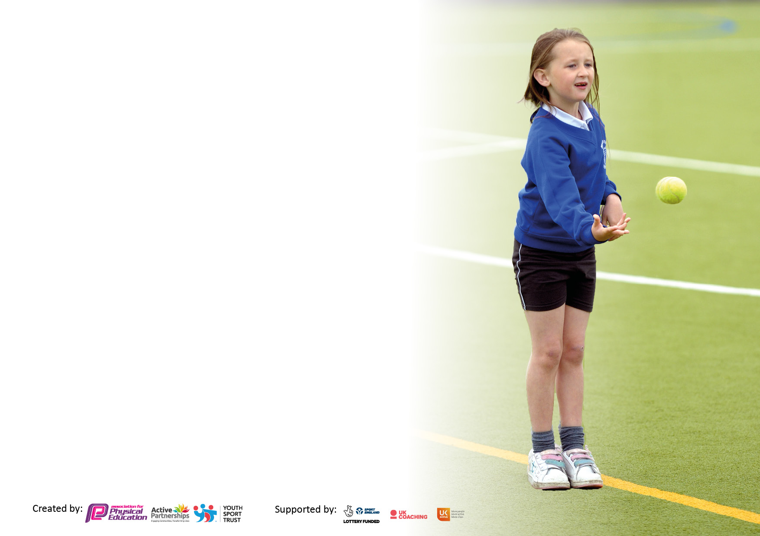

It is important that your grant is used effectively and based on school need. The Education Inspection Framework makes clear there will be a focus on **‘whether leaders and those responsible for governors all understand their respective roles and perform these in a way that enhances the effectiveness of the school’**.

Under the Quality of Education Ofsted inspectors consider:

**Intent** - Curriculum design, coverage and appropriateness

**Implementation** - Curriculum delivery, Teaching (pedagogy) and Assessment

**Impact** - Attainment and progress

To assist schools with common transferable language this template has been developed to utilise the same three headings which should make your plans easily transferable between working documents.

Schools must use the funding to make **additional and sustainable** improvements to the quality of Physical Education, School Sport and Physical Activity (PESSPA) they offer. This means that you should use the Primary PE and sport premium to:

* Develop or add to the PESSPA activities that your school already offer
* Build capacity and capability within the school to ensure that improvements made now will benefit pupils joining the school in future years
* The Primary PE and sport premium should not be used to fund capital spend projects; the school’s budget should fund these.

Pleasevisitgov.ukfortherevisedDfEguidanceincludingthe5keyindicatorsacrosswhichschoolsshoulddemonstrate animprovement.Thisdocumentwillhelpyoutoreviewyourprovisionandtoreportyourspend.DfEencouragesschools to use this template as an effective way of meeting the reporting requirements of the Primary PE and Sport Premium.

We recommend you start by reflecting on the impact of current provision and reviewing the previous spend.

Schools are required to publish details of how they spend this funding, including any under-spend from 2021/2022, as well as on the impact it has on pupils’ PE and sport participation and attainment. **All funding must be spent by 31st July 2023.**

We recommend regularly updating the table and publishing it on your website throughout the year. This evidences your ongoing self-evaluation of how you are using the funding to secure maximum, sustainable impact. Final copy must be posted on your website by the end of the academic year and no later than the 31st July 2023. To see an example of how to complete the table please click HERE.

Created by: Supported by:

**Details with regard to funding**

Please complete the table below.

|  |  |
| --- | --- |
| Total amount carried over from 2021/22 | £1,959 |
| Total amount allocated for 2022/23 | £17,090 |
| How much (if any) do you intend to carry over from this total fund into 2023/24? | £0 |
| Total amount allocated for 2022/23 | £19,049 |
| Total amount of funding for 2023/23. To be spent and reported on by 31st July 2023. | £ 19,049 |

**Swimming Data**

Please report on your Swimming Data below.

|  |  |
| --- | --- |
| Meeting national curriculum requirements for swimming and water safety.  N.B. Complete this section to your best ability. For example you might have practised safe self-rescue techniques on dry land which you can then transfer to the pool when school swimming restarts.  **Due to exceptional circumstances priority should be given to ensuring that pupils can perform safe self rescue even if they do not fully meet the first two requirements of the NC programme of study** | Safe self-rescue was covered during school swimming lessons attended by all KS2 children during the academic year. |
| What percentage of your current Year 6 cohort swim competently, confidently and proficiently over a distance of at least 25 metres?  **N.B.** Even though your pupils may swim in another year please report on their attainment on leaving primary school at the end of the summer term 2022.  Please see note above | 87.5% |
| What percentage of your current Year 6 cohort use a range of strokes effectively [for example, front crawl, backstroke and breaststroke]?  Please see note above | 87.5% |
| **What percentage of your current Year 6 cohort perform safe self-rescue in different water-based situations?** | 87.5% |
| Schools can choose to use the Primary PE and sport premium to provide additional provision for swimming but this must be for activity **over and above** the national curriculum requirements. Have you used it in this way? | Yes/**No** |

**Action Plan and Budget Tracking**

Capture your intended annual spend against the 5 key indicators. Clarify the success criteria and evidence of impact that you intend to measure to evaluate for pupils today and for the future.

|  |  |  |  |  |  |
| --- | --- | --- | --- | --- | --- |
| **Academic Year:** 2022/23 | **Total fund allocated: 19,049** | **Date Updated: July 2023** | | |  |
| **Key indicator 1:** The engagement of all pupils in regular physical activity – Chief Medical Officers guidelines recommend that primary school pupils undertake at least 30 minutes of physical activity a day in school | | | | | Percentage of total allocation: |
| **59%** |
| **Intent** | **Implementation** | | | **Impact** |  |
| Your school focus should be clear what you want the pupils to know and be able to do and about  what they need to learn and to  consolidate through practice: | Make sure your actions to achieve are linked to your intentions: | Funding allocated: | | Evidence of impact: what do pupils now know and what can they now do? What has changed?: | Sustainability and suggested next steps: |
| **To improve the skills and knowledge of children by participating in the delivery of high-quality active PE lessons**  **To replace old and damaged existing PE equipment.**  **To employ a play time leader for lunch times.** | **Amber Valley School Sports Partnership (AVSSP) coaching 1 day per week sports coach to work alongside staff and children in all year groups**  **Purchasing and replacing ‘basic’ PE equipment. This will be after an audit of resources.**  **Increase the activities on offer during a lunchtime.**  **Increase activity levels during lunchtime.** | | **£7580**  **£133.69**  **£3474** | **All children have taken part weekly PE sessions where they have improved their skills across the curriculum.**  **AVSSP planning ensures a clear progression of skills across year groups and across a range of sports.**  **Staff feel more confident in delivery of PE lessons as a result of working alongside a specialist.**  **Audit completed. Required resources ordered.**  **Children have a more positive lunch time experience.**  **Increase in positive behaviour**  **Increase in activity levels**  **Improved teamwork and communication** | **Carry on working with AVSSP to ensure all children receive one lesson per week.**  **Improved quality of delivery for the second lesson of PE as a result of staff CPD.**  **Budget for replacement of equipment to replace old and damaged items from the previous academic year.**  **Continue to budget for additional play leader next year.** |
| **Key indicator 2:** The profile of PESSPA being raised across the school as a tool for whole school improvement | | | | | Percentage of total allocation: |
| 0% |
| **Intent** | **Implementation** | | | **Impact** |  |
| Your school focus should be clear what you want the pupils to know and be able to do and about  what they need to learn and to  consolidate through practice: | Make sure your actions to achieve are linked to your intentions: | Funding allocated: | | Evidence of impact: what do pupils now know and what can they now do? What has changed?: | Sustainability and suggested next steps: |
| **School noticeboard used to display information and celebrate achievements in sport to raise the profile of PE and sport to pupils, parents and visitors.** | * **Noticeboard in place.** * **Display regularly updated.** * **Pupils invited to share sporting success from outside school, these will be celebrated during assembly.** * **School Facebook page used to inform parents and wider community of PE and School Sport at South Wingfield.** | **£ no cost** | | **Curriculum and After School clubs communicated with school.**  **Lunch time competition results shared with the school.** | **Continue to use noticeboard in school and the school website and Facebook page to share information about PE and School sport.** |

|  |  |  |  |  |
| --- | --- | --- | --- | --- |
| **Key indicator 3:** Increased confidence, knowledge and skills of all staff in teaching PE and sport | | | | Percentage of total allocation: |
| 16% |
| **Intent** | **Implementation** | | **Impact** |  |
| Your school focus should be clear | Make sure your actions to | Funding | Evidence of impact: what do | Sustainability and suggested |
| what you want the pupils to know | achieve are linked to your | allocated: | pupils now know and what | next steps: |
| and be able to do and about | intentions: |  | can they now do? What has |  |
| what they need to learn and to |  |  | changed?: |  |
| consolidate through practice: |  |  |  |  |
| **10% of PE Lead salary to** | **Lesson observations of school staff delivering second PE lesson**  **PE lead to attend swimming lessons when all classes go swimming**  **Pupil discussion about PE and sport**  **Training of mini-leaders to deliver activities at lunch**  **Training of mid-day supervisors.**  **Organise events in school such as Tough Rower)**  **Organise and attend competitions with children.** | **£3092.17** | **CF observed 4 PE lessons across the year and provided feedback to staff about strengths and weaknesses.**  **PE lead who holds a level 2 teaching swimming qualification to be released to take all classes swimming for 30 weeks across the school year to ensure a consistent and high-quality delivery of the swimming curriculum.**  **One pupil voice discussion carried out with children from each year group.**  **Mini-leader programme delivered across the year with children in Class 5 delivering weekly activities for younger children at lunch time.**  **Extra experiences arranged for the children to take part in.**  **Children in all year groups had the opportunity to take part in competition and represent the school.** | **Ensure enough release time for PE lead to carry out monitoring of the subject, organsie events and further develop PE and school sport.** |
| **Key indicator 4:** Broader experience of a range of sports and activities offered to all pupils | | | | Percentage of total allocation: |
| **25%** |
| **Intent** | **Implementation** | | **Impact** |  |
| Your school focus should be clear | Make sure your actions to | Funding | Evidence of impact: what do | Sustainability and suggested |
| what you want the pupils to know | achieve are linked to your | allocated: | pupils now know and what | next steps: |
| and be able to do and about | intentions: |  | can they now do? What has |  |
| what they need to learn and to |  |  | changed?: |  |
| consolidate through practice: |  |  |  |  |
| **Tough Runner**  **All children to take part in a Tough Runner event.** | **Tough Runner event booked with AVSSP to deliver event to all children over 1 day.** | **£595** | **All children participated in the event.**  **There was intra-competition across the day.**  **Sporting values promoted throughout the day.** | **Consider booking the event again for the next academic year.** |
| **Tough Rower**  **All children to take part in a Tough Rower event.** | **Tough Rower booked with AVSSP to deliver event to all children over 1 day.** | **£475** | **All children took part in a new activity.**  **All children took part in intra-competition and personal competition.**  **All children were engaged and participated well, including those reluctant children** | **Consider booking the event again, ask Pupil Parliament their thoughts.** |
| **Dance**  **All children to take part in 4 lessons of dance lessons and develop their skills in something new.** | **Booked a block of dance through AVSSP. All children to take part in a 6 week block of dance lessons delivered by a specialist.** | **£900** | **All children took part in dance lessons for their second PE lesson.**  **Children had the opportunity to take part in a dance, delivered by a dance teacher/expert.**  **CPD opportunity for all staff to gain some knowledge of teaching dance.** | **Use pupil discussions to see if children would like to experience more dance or something different.** |
| **Forest Schools**  **All children to take part in two days (or equivalent) of forest schools sessions.** | **AH to organise delivery of forest school sessions for each class across the school year.** | **£2799.14** | **All 5 classes to receive Forest Schools.**  **Experienced outdoor learning.**  **Being active.** | **Plan to delivered to all classes next year.** |

|  |  |  |  |  |
| --- | --- | --- | --- | --- |
| **Key indicator 5:** Increased participation in competitive sport | | | | Percentage of total allocation: |
| 0% |
| **Intent** | **Implementation** | | **Impact** |  |
| Your school focus should be clear | Make sure your actions to | Funding | Evidence of impact: what do | Sustainability and suggested |
| what you want the pupils to know | achieve are linked to your | allocated: | pupils now know and what | next steps: |
| and be able to do and about | intentions: |  | can they now do? What has |  |
| what they need to learn and to |  |  | changed?: |  |
| consolidate through practice: |  |  |  |  |
| **Give as many different children the opportunity to take part in sporting competitions.** | **Enter competitions that are on offer through AVSSP.** | **£ included in AVSSP membership fee.** | **Different groups of children across all age groups have attended various competitions throughout the year including: athletics, handball, dodgeball, basketball, cross country.**  **Our best achievement this year was reaching the county finals in basketball where the team came 2nd.** | **Ensure that each class has the opportunity to attend sports competitions.  Once per term.** |

|  |  |
| --- | --- |
| Signed off by | |
| Head Teacher: |  |
| Date: |  |
| Subject Leader: | C. Fisher |
| Date: | July 2023 |
| Governor: |  |
| Date: |  |