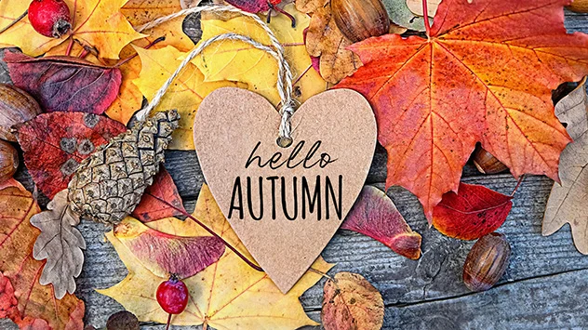 **Class 3 Newsletter - Autumn**

Welcome back! We hope you’ve all had a good summer break.

Class 3 has two teachers, Mrs Williams and Mrs Wood and we are so excited to be working with Class 3 this year. We also have two teaching assistants Mrs Colman and Mrs Wilmot. We have lots of fun and interesting things planned, including themed days and trips later in the year.

Class 3 are known as ‘Class 3 Kingfishers’ and in our first week back we will collect lots of facts about kingfishers. Here are a few of them;

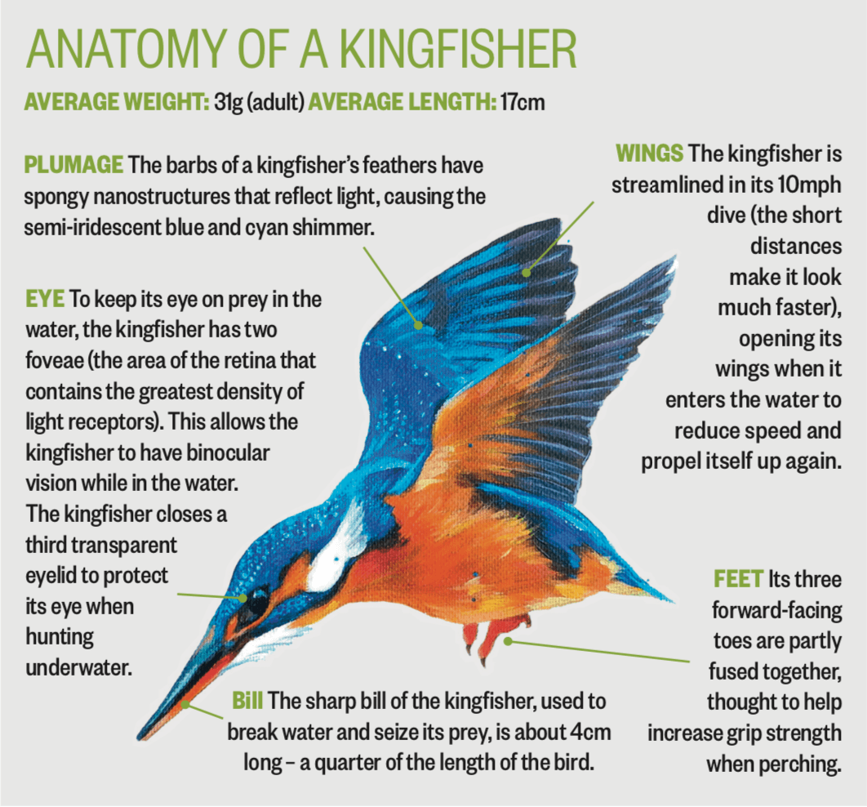

**Our topic for Autumn 1 is the UK**

This term the children will take a look at the geography of the UK - from the physical features of mountains, rivers and seas to the man-made administrative regions and counties. They will find out how the UK has changed over time, looking at how London grew and how the population of the UK as a whole has changed throughout the course of history

Please check out on the school website for more detail of the other subjects we will be studying during the autumn term, including knowledge organisers.

**Logins and passwords**

We have given your child a folder which SHOULD BE KEPT IN A SAFE PLACE **AT HOME** PLEASE. It will contain their spellings for the year. In future, termly spellings will also be posted on the website for you to refer to if you wish. You should also have received;

* Logins and passwords for TT Rockstars, Charanga, Sumdog and Spelling Shed, learning platforms.
* Lists of Statutory Spellings (words children should know how to spell independently by the end of this year).
* Spelling, grammar and punctuation terms. (Word classes and definitions that children should learn for spelling, grammar and punctuation).
* Knowledge organisers giving information and vocabulary on some of the topics we will be studying this term.

**Please add these to the folder you have been given for future reference and safe keeping. PLEASE KEEP THE FOLDER AT HOME.**

**Keeping you informed**

At the beginning of each term we will post on the School website termly information, including spellings, knowledge organisers and key events. These will include everything that you and your child will need to know ready for the upcoming term. This is to save on paper, so please do keep checking the website for recent school newsletters and information too.

**PE in Class 3**

Children will have PE twice a week. One session will be taught by Amber Valley on Tuesdays and the other will be taught by Mrs Wood on Fridays. Children should come to school dressed in their PE kit on the days that they have PE. This consists of plain blue or black shorts, a plain white or blue T-shirt, plain black or blue jogging bottoms or leggings, a plain blue or black sweatshirt or hoodie and trainers with grip. Children should not be wearing branded tracksuits or football gear, sparkly t-shirts or fashion wear. Canvas shoes or sandals are not safe when taking part in physical activity. No earrings should be worn to school on these days please and long hair should be tied up.

Class 3 Kingfishers will go swimming in the summer terms.

**Reading expectation in school and at home**

In school your child will be part of daily guided reading groups and will also read individually to an adult at school. They will be expected to read ideally 5 times each week at home too. It does not always have to be their reading book, it may be a book of their own choice, a comic or even a newspaper. It would be helpful if reading at home was recorded in their reading record and signed by an adult each time, we need this in order to change children’s books appropriately. **Please fill in one box in the reading record book for each day your child reads.**

Your child has been given a reading record and a reading packet that they can use to keep their reading record and reading books in. They will need to bring this into school daily and place in their tray.

**Homework in Class 3**

There is an expectation that your child regularly logs onto TT Rockstars, Sumdog and Spelling Shed at home to complete tasks we have set for them**.**  We will be monitoring how often your child logs onto these online platforms, so that we may identify any areas/difficulties that may need further addressing, e.g. a particular times table or spelling pattern.

Please encourage your child to learn their times tables off by heart at home to support learning in school. We will be learning times tables daily and reciting them as well as completing weekly times tables tests on Fridays.

Alongside online homework, we would like your child to complete 2 pieces of homework each term relating to the topic that we are learning in class. Our topic for Autumn 1 is the UK. We have attached a homework grid for your child to choose 2 tasks from. Children’s homework may take any form. It could be a PowerPoint presentation, a piece of writing, a combination of typed up research and hand-drawn pictures, a comic strip or they might like to do some artwork or produce a model, write a story, song, or poem. Children can complete their piece of topic homework at any point during Autumn term and they are more than welcome to bring it into school to show the rest of the class and, if possible, have it added to our topic display. However, if you would prefer to email your child’s topic homework to school then that is absolutely fine too! We can then print a picture of it out for display.

**Musical instruments**

This year your child will have the fantastic opportunity to learn to play a musical instrument. This year it will be violin. Music lessons will be delivered by the Classroom Instrumental Learning Team and will start on 20th September. (More details to follow).

**Other useful information**

* If possible, could all uniform and water bottles please be clearly labelled**!** Children will keep their jumpers on their pegs if they take them off and their water bottles will stay on their desks throughout the day. However, making sure everything is labelled ensures good hygiene is followed and ensures there are no mix ups at home time!
* No toys are allowed in school, including trading cards.
* Mrs Wilmot will teach the children on alternate Monday afternoons.
* Every Friday your child will have a weekly spelling test of usually ten words. We will ask your child to write their weekly spelling score in their reading record.
* Your child will have a times table test each Friday. This term will be mainly concentrating on the 2x, 5s and 10x tables.
* Your child has all the stationery they require in school. Please do not send in pencil cases or stationery.

**SNACKS**

A snack at break time is nice to have. Your child should bring in healthy snacks into school, **PLEASE….NO NUTS.** Some examples for snacks;

* Whole or sliced fruit.
* Vegetable sticks, e.g. celery, carrot, pepper, cucumber. ...
* Bag of plain popcorn.
* Bread sticks.
* Rice or corn cakes

If you have any questions or concerns, please do not hesitate to contact us – preferably at the end of the school day – when we will have a little more time and be more than happy to discuss anything.

*Mrs Williams & Mrs Wood*