Mountain, Rivers and Coast Homework Grid – Please choose 2 activities to complete this term
Make a list of ways that water is essential to people, plants and animals. What would happen if there was no more rain?   | Design and make a 3D model of a river, from source to mouth. Can you label it with its different features too? e.g. ox bow lake, meander…  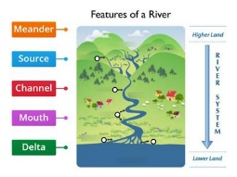 | Create a true or false quiz about rivers or mountains.  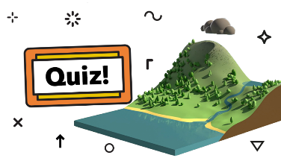 | Read some poems about a rivers journey (find on internet) and see if you can write an acrostic poem, a shape poem or your own river journey poem.  ‘River journey’ poem – Primary KS2 teaching resource - Scholastic
- A rivers depth relies on rainfall. Make a rain gauge and keep a record of how much rain falls over 3 weeks. Produce a table and graph to show your results.  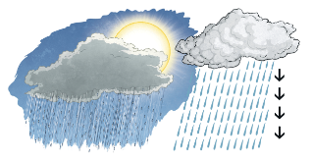 | Design and make a bridge to cross a busy river. What will you make it out of? How will you make it a strong structure?  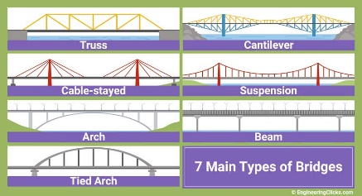 | Make a poster about being safe in and around water?   | Nico Klopp is a famous artist who painted a lot of rivers . Can you find 5 facts out about his artist?  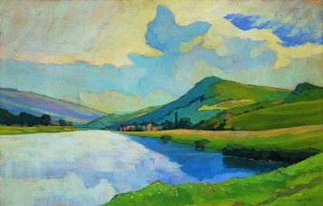
Make your own map of rivers in the UK. Take care to draw accurately and label each river neatly.  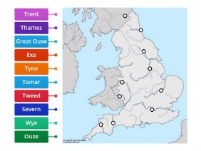 | Write an adventure story featuring mountains and rivers. Make sure it has exciting events and language to keep the reader engaged throughout.  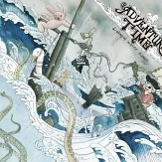 | Complete some local research and find out which rivers flow through/around Alfreton where do they go to? Can you make a fact file about them?  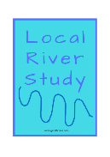 | Research one river in detail and present the information in a non-chronological report.  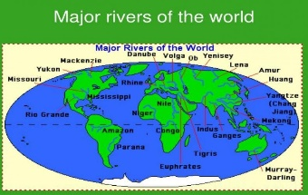
Research a mountain and make a leaflet of facts (include pictures)  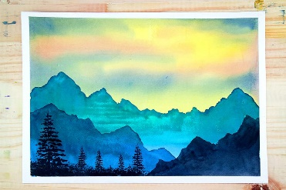 | How are mountains formed? Create a short power-point presentation to teach people. ( remember to print out your ppt to bring to school)  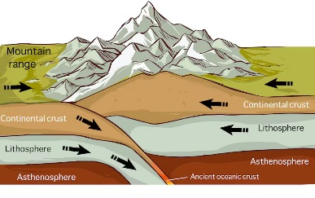 | Create a mountain range! You could paint, draw with pencil crayons, use oil pastels, use the computer programme ‘paint’ or any medium you prefer.  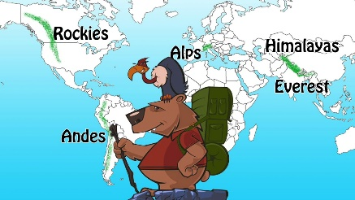 | Yodelling is always associated with mountains. Can you find out about its history and culture? Present it how you please.  

