SPAG  Linking to writing a narrative-  - Adverbs  - Nouns and pronouns  - A wider range of conjunctions  - Correct use of simple present  - Fronted adverbials  - Second person  - Paragraphs  - Adjectives  The weekly spelling patterns will be included in our SPAG lessons too. | English  Writing a Narrative-  In English this term the children will be reading The Akimbo Adventures. The children will be taking inspiration from this to have a go at writing their own short adventure story based in Africa.  For our reading for pleasure book this term Class 4 will be continuing to read the second book in our series Return to Roar  For our topic book this term C4 will be reading The Akimbo Adventures  For our poetry book this term C4 will be reading | Geography: Exploring Africa  During our topic this half term children will be exploring the amazing continent of Africa. Exploring each of the five regions, children will start to get an understanding of just how diverse the continent of Africa is and find out about the human and physical geography of a number of African countries.  
Maths  During our Spring term both Year 4 and Year 5 children will be focussing on Fractions, decimals, percentages and perimeter and area. We will be following the scheme White Rose Maths. Children’s SumDog homework will link to what we have been learning in lessons.  Times Table of the Term (Children’s TT Rockstar’s test on a Friday will be based on these times table) – Both Y4 and Y5 children will be working on mixed times tables this term.  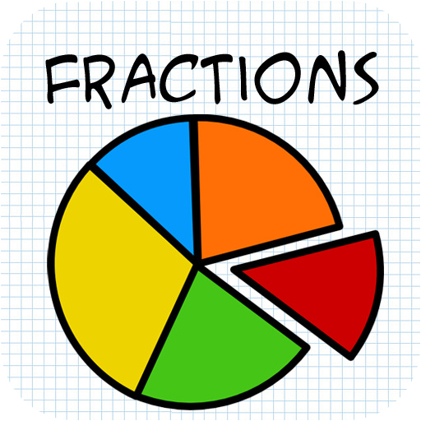 | Science: Forces  This ‘Forces’ unit will teach about types of forces such as gravity, friction, water resistance and air resistance. Children will also learn about the use of mechanisms such as levers, gears and pulleys. The children will identify forces and find out about Isaac Newton and his discoveries about gravity. Finally, they will find out about different mechanisms, including levers, gears and pulleys, and will design their own marvellous machine.   | PSHE- Money Matters  We will be following the PSHE Matters scheme, and during the Spring term we will be looking at money matters.  Understanding different ways to keep track  of money.  - Understanding the risks associated with money and ways of keeping money safe.  - Identifying the risks involved in gambling activities.  - Identifying there is a broad range of different jobs/careers.  - Recognising some of the skills that will help them in their future careers.
PE  In PE we will be doing PE with Amber Valley on a Tuesday. We will also be doing a second PE lesson on a Wednesday. Miss Wareham will be taking Class 3 swimming so Mrs Williams will be doing PE with Class 4 on a Wednesday afternoon.   | DT- Cooking and nutrition  In DT this term children are looking at adapting a recipe. Children will be able to:  - Describe features of biscuits using taste, texture and appearance.  - Follow a recipe with support.  - Use a budget to plan a recipe.  - Adapt a recipe using additional ingredients.  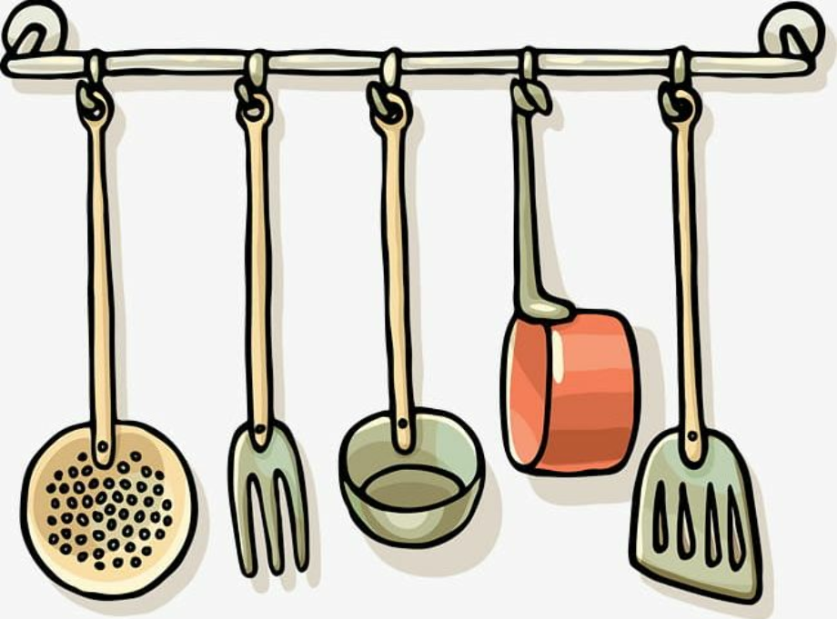 | French- Eurovision  In French this term we are looking at Eurovision. By the end of the unit children will be able to:  - Match a set of instrument words to the appropriate instrument picture,  - Say which instrument they play.  - Say what kind of music they like, using a whole sentence.  - Read and understand music genres in written form.  - Recall country names with accurate pronunciation.  - Write information in French about a character from a different country.  - Perform a song from memory with accurate pronunciation.  
Computing- Mars Rover 1  Children will be following the Kapow unit Mars Rover 1. Children will be able to:  - Identify some types of data the Mars Rover could collect (for example, photos).  - Explain how the Mars Rover transmits the data back to Earth and the challenges involved.  - Read any number in binary, up to eight bits.  - Identify input, processing and output on the Mars Rovers.  - Read binary numbers and grasp the concept of binary addition.  - Relate binary signals (Boolean) to a simple character-based language, ASCII.  . | RE- If God is everywhere why go to a place of worship?  Describe and explain differences within Anglican and Baptist churches  • Make links between Christian beliefs and features of these places of worship. • Describe differences between worship in the home and at the mandir  • Describe the differences between different Jewish synagogues.  • Make links between Jewish beliefs and features of Jewish places of worship.  • Describe what places of worship are for  • Describe what people from different religions would say the most important function of their place of worship is  • Make links between Hindu beliefs and  worship.  • Give examples of how places of worship are helpful to believers in difficult times  • Explain how and some people see the place of worship as being more about the people than the building | Music- Charanga  We follow the scheme Charanga for our music lessons, children will be looking at the unit Dancing in the street.  

