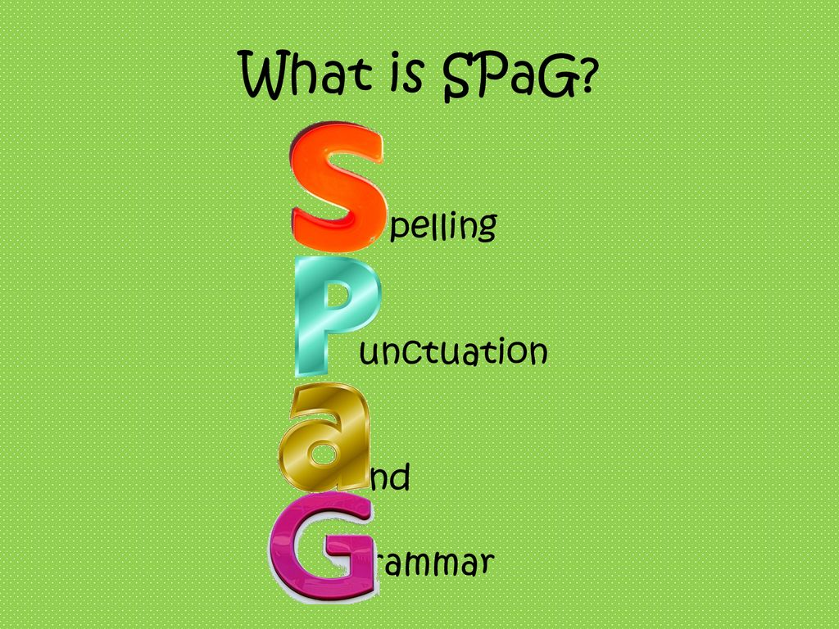  - Nouns and pronouns for clarity  - Consonants and vowels  - Suffixes – ly  - Past tense  - Subordinate clauses  - Revision and assessment  - Adjectives  - a or an  - prefixes – super, anti and auto  - Present tense  - Apostrophes  - Revision and assessment  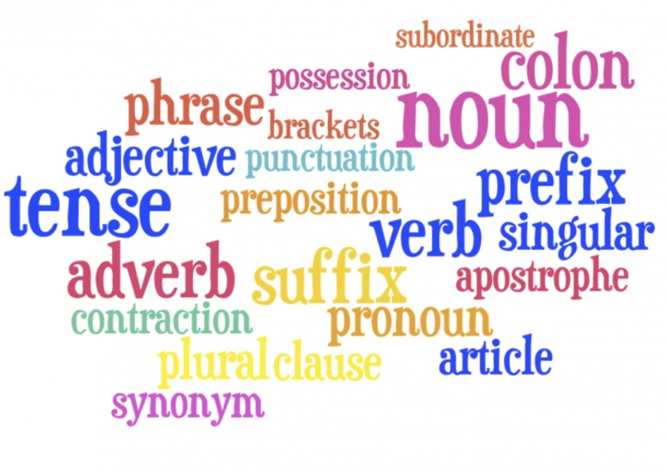 | English  - Writing to entertain Characters and Settings  - Myths and Legends  - Performance poetry – Bug Chant  - Writing to inform Newspaper recount  - Instructions  - Festivals poems from around the world  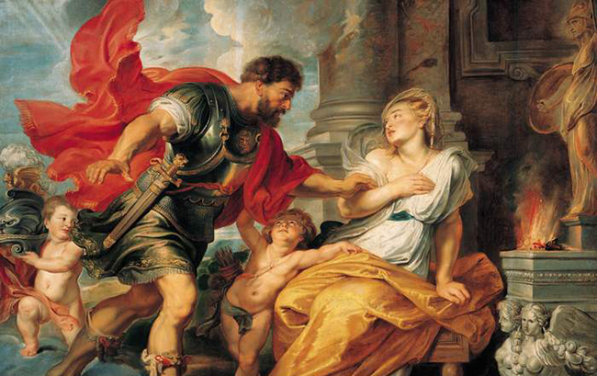  Children will become familiar with the famous Roman myths and in particular that of Romulus and Remus. They will work in groups to retell the myth, focusing on key moments from the story. Using drama to explore characters and relationships, they will plan and write their own retelling of the myth with a particular focus on the story’s dilemma and resolution. They will also learn how to analyse, plan, write and edit personal recounts based around events within the myth. Children will also produce descriptive poems where they will use expanded noun phrases and fronted adverbials for added detail and effect. | Topic: Why were the Romans thought to be revolutionary?  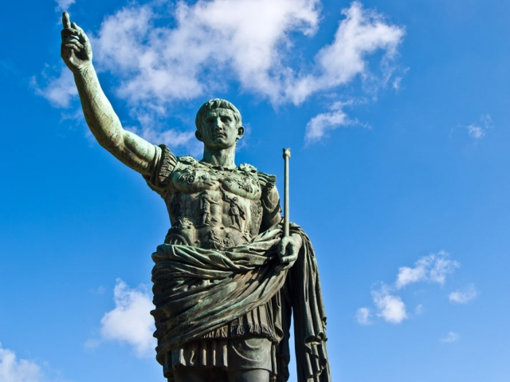  This term we will learn about the impact the Roman empire had on life in Britain. They will learn about the spread of the Roman empire, the invasion of Britain and the eventual conquest. The children will also look in detail at some aspects of the Romanisation of Britain, such as the building of Roman roads and bathhouses. In addition to this, they will have the opportunity to learn about the British resistance of Boudicca and will act in role to look at the events of Boudicca's rebellion from different perspectives. The children will also investigate Hadrian's Wall, examining how, where and why it was built. They will learn about the different features of the wall and use maps to determine its location. A lesson on gods and Roman religion will help the children to understand more about the culture and beliefs of Roman people, and they will play and design games to consolidate their knowledge about the different Roman gods and goddesses.
Maths  - Place value  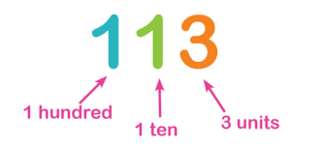  - Addition and subtraction  - Multiplication and division  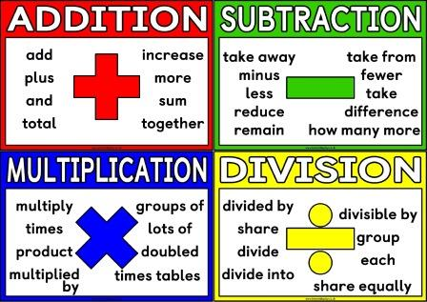  - Times tables  Times tables:  Weekly tests on Mondays and Fridays  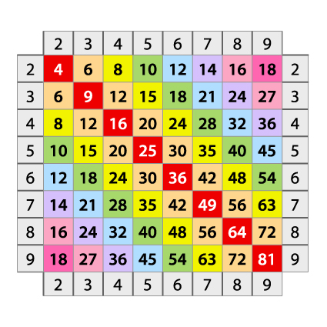 | Science  - Light  This ‘Light’ unit will teach your class about light, reflections and shadows. They will learn about different sources of light, and that we need light to see. The children will work scientifically and collaboratively to investigate reflective materials, in the context of designing a new book bag. They will work in a hands-on way to play a range of mirror games, finding out more about reflective surfaces. Furthermore, they will learn that the sun’s light can be dangerous, and will create an advert for a pair of sunglasses or a sun hat that they have designed. The children will have chance to test which objects are opaque in an exciting investigation to design the most effective curtains, and will find out how shadows change when the distance between the object and light source changes. They will develop their scientific enquiry skills, making observations, predictions and conclusions.  States of Matter  This ‘States of Matter’ unit will teach your class about the differences between solids, liquids and gases, classifying objects and identifying their properties. The children will work scientifically and collaboratively to investigate the weight of a gas. Furthermore, they will have chance to find the ideal temperature to melt chocolate. They will explore in-depth how water changes state, exploring melting, freezing, condensing as well as a particular focus on evaporation. Finally, they will learn about the stages of the water cycle, creating mini water worlds and an interactive water wheel to represent the different stages. | Safety and the Changing Body  We will be looking at internet safety, first aid, privacy and secrecy, tobacco and growing up.  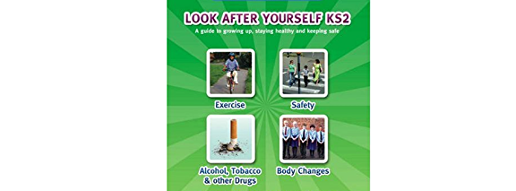
French - Shopping in France

The children will learn about the shopping experience in France. Children will learn specific vocabulary of fruit, vegetables and clothes. They will learn key phrases for asking the questions needed when going shopping. The unit concludes with a role play lesson, where children will take on the roles of shoppers and shopkeepers.

Computing

Online safety
Networks
PE  Amber Valley will continue to take one PE session and this term and the second session it will be on…..  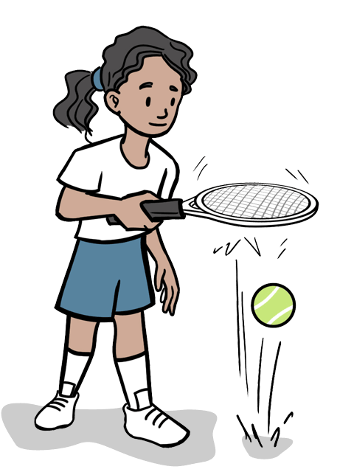 | Art/DT  The children will be making roman bread, roman shields, mosaics and collage.  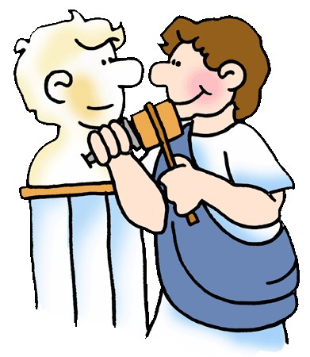 | Music – Dancing in the Street  We will be exploring body and tuned perscussion to make music. We will be exploring a variety of 1960’s songs.  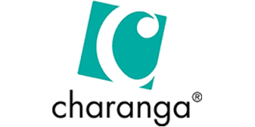
RE
What do different people believe about God? ((Intro to Hindus) Christians, Hindu* Muslims)

This topic enables pupils to learn in depth from different religious and spiritual ways of life regarding diverse beliefs about God. The investigation implements the principal aim of RE, which is to engage pupils in systematic enquiry into significant human questions which religion and worldviews address, so that they can develop the understanding and skills needed to appreciate and appraise varied responses to these questions, as well as develop responses of their own.

Why is the bible so important to Christians? (Christianity, Christians)
In this topic on the Bible will look at the Bible in Christianity, its origins, its role as a sacred religious text and how it is used by Christians around the world. Children will consider the authorship of the Bible, discussing the Christian belief that it is the Word of God whilst finding out about different writers of books in the Bible. They will discuss the different text types used in the Bible and explore a story in greater depth. Children will apply their learning to consider an item or book that is sacred to them, and reflect on how respect can be shown to things that are sacred to others.

Some brilliant online games and activities to try

https://rome.mrdonn.org/games.html

https://bookunitsteacher.com/ancient_rome/online_activities.htm

https://www.imagininghistory.co.uk/post/roman-crafts-for-kids-live-like-a-roman-in-britain

