South Wingfield

Phonics Information Booklet

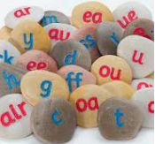

2022-2023

**What is Phonics?**

Phonics is a way of teaching children to read quickly and skilfully. They are taught how to: - recognise the sounds that each individual letter makes; - identify the sounds that different combinations of letters make such as /sh/ or /ee/; and - blend these sounds together from left to right to make a word. Children can then use this knowledge to ‘decode’ new words that they hear or see. This is the first important step in learning to read.

**Why Phonics?**

Research shows that when phonics is taught in a structured way – starting with the easiest sounds and progressing through to the most complex – it is the most effective way of teaching young children to read. It is particularly helpful for children aged 5 to 7.

Almost all children who receive good teaching of phonics will learn the skills they need to tackle new words. They can then go on to read any kind of text fluently and confidently, and to read for enjoyment. Children who have been taught phonics also tend to read more accurately than those taught using other methods, such as ‘look and say’. This includes children who find learning to read difficult, for example those who have dyslexia.

(The information above is directly from the Department of Education’s ‘Learning to read through phonics: information for parents’ document.)

**How Phonics is Taught at South Wingfield?**

At South Wingfield we have devised our own Phonics scheme, which was praised in the recent OFSTED inspection for having clear rigour and detail. We have used the best elements from the schemes available and produced our own approach which meets the needs of our children.

We follow the Letters and Sounds order of sounds and tricky words, alongside using the Read, Write Inc mnemonics to provide children with another method to support their learning.

In Reception and Year 1, children receive daily phonics lesson (15-20 mins) where they recap the tricky words and sounds they already know followed by the introduction of the new tricky word and sound. They then use this knowledge to help them to segment and blend words to read and write.

In addition to this child are heard to read on a 1 to 1 basis where their phonetic skills are practised along with Guided Reading sessions (Year 1.) They also receive a weekly spelling check, the words given are directly related to the sounds taught in their sessions.

Children are assessed regularly and interventions are put in place to ‘plug the gaps’. All Year 1 children will sit a Phonics Screening Check in June, where they will read a mixture of real and nonsense words.

During their time in Reception all children will be taught the letter names along with the corresponding phonemes for Phases 2-4. In Year 1 children will consolidate their knowledge of Phase 3 and 4 phoneme alongside the alternative phonemes covered in Phase 5.

**Phonics Terminology**

* Phoneme- the sound a letter(s) make
* Grapheme- is the letters that make up a phoneme
* Diagraph- two letters that make one sound e.g. oa in boat.
* Trigraph- three letters that make one sound e.g. igh in light
* Segmenting- breaking a word up into sounds.
* Blending- putting the sounds together to read a word
* Tricky words- words that cannot be easily decoded.
* Pure sounds- using the phonetic sound e.g. t not tuh
* Fred Fingers- Used to sound out words.
* Sausages (lines) and peas dots)- used for children to help identify the phonemes in words.
* Consonant diagraph- diagraphs which start with a consonant e.g. ch, sh, th, ng

**Phoneme Order**

|  |  |  |
| --- | --- | --- |
| **Phase 2 Set 1 Sounds** | | |
| S | a | t |
| P |  |  |
| **Phase 2 Set 2 Phonemes** | | |
| I | N | m |
| D |  |  |
| **Phase 2 Set 2 Words** | | |
| **i** – *it, is,* sit, sat, pit, tip, pip, sip  **n**–*an, in,* nip, pan, pin, tin, tan, nap  **m** – am, man, mam, mat, map, Pam, Tim, Sam  **d** – *dad, and,* sad, dim, dip, din, did, Sid | | |
| **Phase 2 Set 3 Phonemes** | | |
| g | o | c |
| k |  |  |
| **Phase 2 Set 3 Words** | | |
| **g**– tag, gag, gig, gap, nag, sag, gas, pig, dig  **o** –*got, on, not,* pot, top, dog, pop, God, Mog  **c** – *can,*cot, cop, cap, cat, cod  **k** – kid, kit, Kim, Ken | | |
| **Phase 2 Set 4 Phonemes** | | |
| ck | e | u |
| r | h | b |
| **Phase 2 Set 5 Words** | | |
| **ck** – kick, sock, sack, dock, pick, sick, pack, ticket, pocket  **e** – *get*, pet, ten, net, pen, peg, met, men, neck  **u** – *up, mum,* run, mug, cup, sun, tuck, mud, sunset  **r** – rim, rip, ram, rat, rag, rug, rot, rocket, carrot  **Phase 2 Set 6 Phonemes** | | |
| f | ff | l |
| ll | ss |  |
| **Phase 2 Set 6 Words** | | |
| **h** – *had, him, his,* hot, hut, hop, hum, hit, hat, has, hack, hug  **b** – *but, big, back,* bet, bad, bag, bed, bud, beg, bug, bun, bus, Ben, bat, bit, bucket, beckon, rabbit  **f, ff** – *of, if, off,* fit, fin, fun, fig, fog, puff, huff, cuff, fan, fat  **l, ll** – lap, let, leg, lot, lit, bell, fill, doll, tell, sell, Bill, Nell, dull, laptop  **ss** – ass, less, hiss, mass, mess, boss, fuss, hiss, pass, kiss, Tess, fusspot | | |
| **Phase 3 Set 6 Phonemes** | | |
| j | v | w |
| x |  |  |
| **Phase 3 Set 6 Words** | | |
| **j** – *jug, jet, Jim, Jack, Jess, jam, jog*  **v** – *van, vet, vat, Viv, vex*  **w** – web, wag, wax, will, well, wet  **x-** box, fox, fix, mix, tax, six | | |
| **Phase 3 Set 7 Phonemes** | | |
| y | z | zz |
| qu |  |  |
| **Phase 3 Set 7 Words** | | |
| **y** – *yet, bay, lay, pay, yet, yak, yo-yo, yuck*  **z** – *zip, zap, Baz, Liz, Zac*  **zz** – buzz, jazz, fuzz, fizz,  **qu-** quit, quill, quack, quick | | |
| **Phase 3 Consonant Diagraph Phonemes** | | |
| ch | sh | th |
| ng |  |  |
| **Phase 3 Consonant Diagraph Words** | | |
| **ch** – *chips, chop, much, hutch, cha, check*  **sh** – *shop, ship, bush, wish, fish, shock, shed*  **th** – bath, path, that, think, thick, moth, path, thin  **ng-** ring, thing**,** bang, rang, song, wing. | | |
| **Phase 3 Vowel Diagraph Phonemes** | | |
| ai | ee | igh |
| oa | oo | ar |
| or | ur | ow |
| oi | ear | air |
| ure | er |  |
| **Phase 3 Vowel Diagraph Words** | | |
| **ai** – *snail, rain, pain, train, sail, hail, aim.*  **ee** – *sheep, feet, meet, weep, keep, cheer, sheet.*  **igh** – *high, fight, sight, light, night, might, sigh*  **oa-** *boat, goat, float, toast, soap, oak, road*  **oo** – *took, book, look, foot, wood, hook, look.*  **ar** – *car, sharp, start, part, cart, bark, card, hard*  **or** – *born, sort, cord, fort, worn, corn, north, worn*  **ur-** *burn, turn, burp, turnip, burst, surf, hurt*  **ow-** *cow, now, owl, town, down, towel, scowl, crowd.*  **oi** – *oil, soil, boil, hoist, point, coin, spoil, tinfoil*  **ear**– *fear, tear, year, rear, shear, spear, earwig*  **air** – *fair, hair, pair, lair, chair, airship, flair, unfair*  **er-** *her, her, fern, verb, herb, winter, boxer, better* | | |
| **Phase 5 Phonemes** | | |
| ay | ew | ou |
| Ie | ea | oy |
| Ir | ue | aw |
| wh | ph | oe |
| au | a-e | e-e |
| i-e | o-e | u-e |
| **Phase 5 Words** | | |
| **ay** – *day, pay, play, stray, player, birthday, pray,*  **ew** – *chew, stew, new, crew, newt, threw, flew*  **ou** – *out, shout, sound, ground, spout, sprout*  **ea-** *tea, team, seat, peach, jeans, pea, beak*  **oy**– *toy, boy, royal, joy, boy, oyster, enjoy, cowboy*  **ir** – *twirl, girl, dirt, bird, skirt, shirt, first, birth, thirteen*  **ue** – *glue, blue, cue, rescue, argue, duel, bluebell*  **aw-** *yaw, dawn, lawn, jaw, paw, drawers, claws*  **wh-** *whip, which, whisper, whip, whiskers*  **ph** – *dolphin, phonics, alphabet, sphinx*  **oe**– *toe, tiptoe, woe, Joe, foe*  **au** – *haul, taunt, August, launch, haunt, Paul*  **a-e**- *cake, bake, hate, late, flame, name, snake, rake*  **e**-**e**- t*heme, scheme, eve, Pete, even, these*  **i-e**- *hide, slime, smile, slide, nice*  **o**-**e**- *phone, home, alone, hose, hope, broke*  **u**-**e-** *tube, flute, prune, cute, huge, rude, cube, June* | | |

**Sound Families**

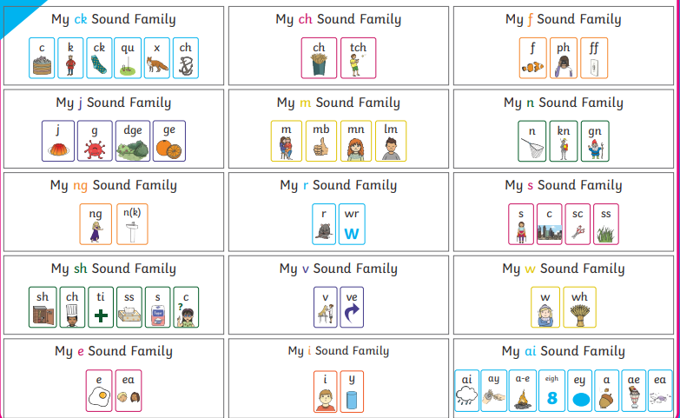

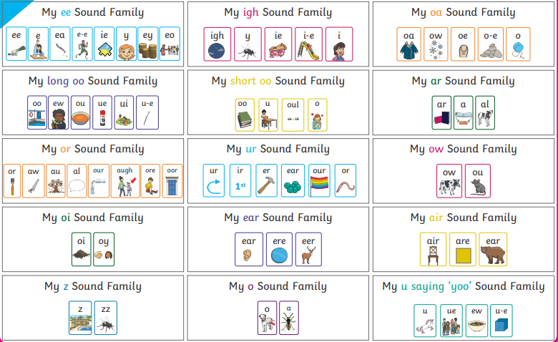

**Tricky Word Order**

|  |  |  |
| --- | --- | --- |
| **Phase 2 (Reception)** | | |
| the | to | I |
| No | go | into |
| **Phase 3 (Reception)** | | |
| you | they | all |
| are | my | her |
| He | she | we |
| me | be | was |
| **Phase 4 (Reception)** | | |
| said | do | like |
| come | there | little |
| out | have | so |
| some | were | one |
| when | what |  |
| **Phase 5 (Year 1)** | | |
| oh | could | there |
| people | Mr | Mrs |
| looked | called | asked |

**How to Help at Home**

* **Listen to your child read daily.** If your child stumbles on a word, encourage them to sound it out. But if they still can't get it, provide the word so they don't get discouraged. Reading books will only be changed once a week, this is to encourage the children to re-read the books, which will in turn increase their confidence, word recognition and ultimately **fluency.**
* **Make flashcards of sounds and words-** alternatively they can be downloaded from [Letters and Sounds – Free phonics resources for the Letters and Sounds programme (letters-and-sounds.com)](https://letters-and-sounds.com/)
* **Practice your child’s spellings-**  refer to the back of the booklet for a range of ideas- try to avoid copying the spellings out over and over again.
* **Join the library-** it is free and they hold lots of events throughout the year to encourage reading.
* **Revisit familiar books.** It's okay if your child wants to re-read favourite books from earlier years. In fact, it's actually beneficial!
* **Read aloud.** Choose books on topics that excite your child (get great suggestions from our [book lists](https://www.scholastic.com/parents/books-and-reading.html)), and read with gusto, using different voices for each character.
* **Spread the joy.** Show your child how much you value reading by having plenty of books and magazines around the house. You'll practice phonics as well as cultivate a lifelong love of reading.

**Comprehension**

As part of the development of reading children are encouraged to ask and answer questions about the text they have read or heard.

**Reception Comprehension Questions**

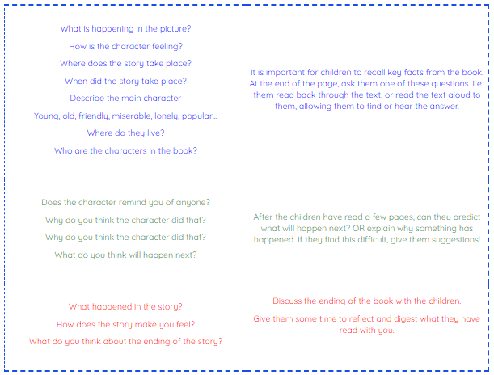

**Year 1 Comprehension Questions**

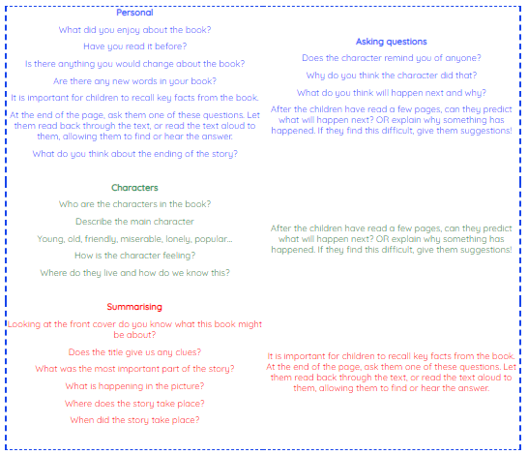

**Games and Ideas**

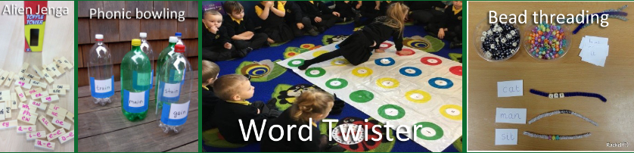 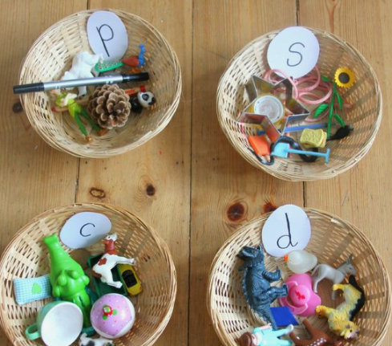 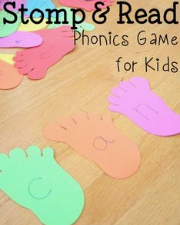 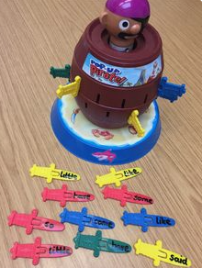 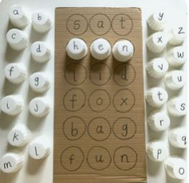 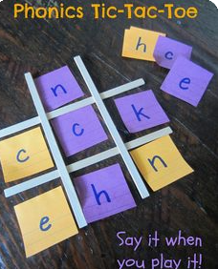 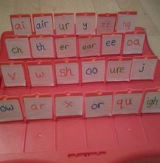 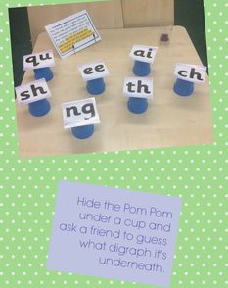 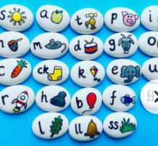 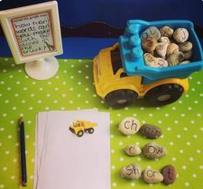

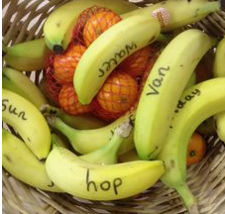 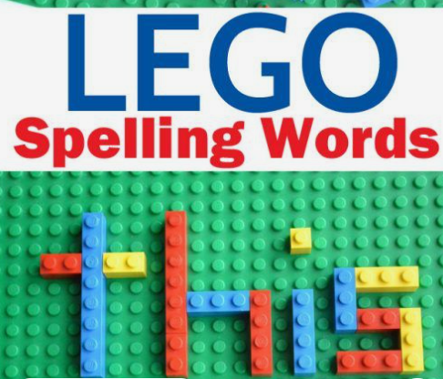 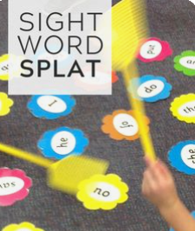 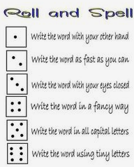 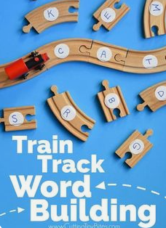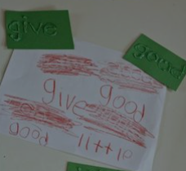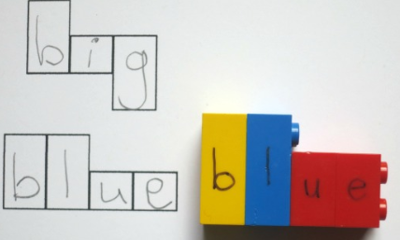 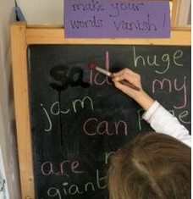 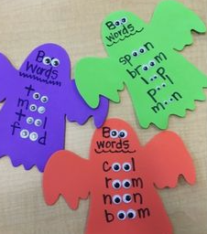 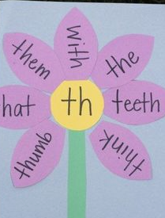 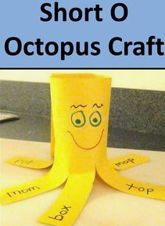 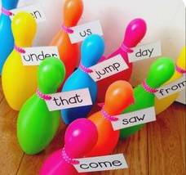 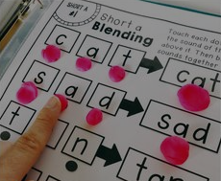 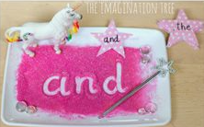 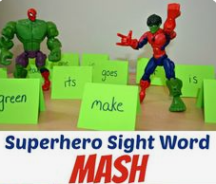

**Website Links**

The following websites will help you support your child at home with their phonics (most of them are free):

[www.lettersandsounds.com](http://www.lettersandsounds.com)

[www.galacticphonics.co.uk](http://www.galacticphonics.co.uk)

[Letters and Sounds, English Games for 5-7 Years - Topmarks](https://www.topmarks.co.uk/english-games/5-7-years/letters-and-sounds)

[www.phonicsplay.co.uk](http://www.phonicsplay.co.uk) (username and passwords Wingfield123)

[Phonics Games for the Classroom and Home - Phonics Bloom](https://www.phonicsbloom.com/)

[www.topmarks.co.uk](http://www.topmarks.co.uk)

[Mr T's Phonics - YouTube](https://www.youtube.com/channel/UC7sW4j8p7k9D_qRRMUsGqyw)

https://www.phonicsplay.co.uk<http://www.familylearning.org.uk/phonics_games.html>