Year 1
Spring 2 Overview

Antarctica
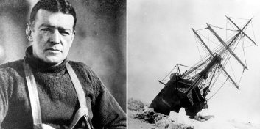

English  In English children will be writing and performing a poem linked to their knowledge of Antarctica. They will use vivid description to paint the picture in the reader’s mind. They will then use their knowledge of Ernest Shackleton to write his biography. | Maths  Children will be completing their money unit, they will learn to recognise coins, and notes, add them together and find the change from an amount. In addition, to this they will start their multiplication and division unit. To support this please can you encourage your children to practise using TT Rockstars. | Topic  In History children will be considering what makes a ‘significant’ figure. They will then learn about the famous explorer Ernest Shackleton and his famous explorations of Antarctica.
RE  In RE children will be learning about the Christian celebration of Easter and why it is important in the Christian calendar/ | PSHE  In PSHE we will be exploring different emotions and use the book “The Colour Monster” to help us do this. We will name different feelings and think about how our feelings can impact our thoughts and behaviours. We will discuss who we can talk to when we feel certain ways and how we can manage our feelings. | Computing- Stop Motion  - Children will create a flip book animation.  - They will decompose a story into smaller parts to plan a stop motion animation. They will then create stop motion animations with small changes between images.
Music  Our music topic is called ‘Zoo Time’  Children will find the pulse and know this unit is about Reggae music. They will understand that songs have musical style and name some instruments they can hear. | PE  In PE this half term we will have an extra PE slot where the children will have a Martial Arts teacher deliver age appropriate Martial Arts. This is a fantastic opportunity for the children to learn about the sport. | Science  Children will be learning all about different plants. They will name several flowers and learn the parts of flowers and trees. They will learn about what plants need to survive and complete an investigation around plants in the light and dark. Children will observe, participate and analyse a fair test.
Art and DT

This half term the children will be designing and making their own puppet. They will experiment joining materials using pins, staples and glue. They will then design a puppet and use a template, and then decorate their puppet to match their design.

